Competitive Landscape Analysis Workbook
One file. You lead the analysis; the AI is your research assistant. Validate everything it gives you.

READ ME FIRST (for the student)
This single file replaces the separate input and output documents. You drive the strategic thinking; the AI helps research and brainstorm. The whole point of the assignment is that you confirm, contest, and augment what the AI gives you — simply accepting the AI's output without challenge lowers your grade.

How this works:
- Do the PRE-WORK first (no AI): research your market, list competitors you already know, and draft a few comparison dimensions.
- Fill the blue PROBLEM and JOBS-TO-BE-DONE sections, then SAVE and upload the file to your AI. The instruction block tells it what to do.
- Work through the deliverables in order — Competitors → Leaders Quadrant → SWOT → Harvey Balls. For each one: the AI drafts (green), then you validate, correct, and add your own view (blue).
- Paste each AI output into its green box and write your validation in the blue box. Save and re-upload the workbook whenever the AI needs the latest full picture for a later stage.
- Finish with your Learning narrative and Lean Canvas update — these are NO-AI sections you write yourself.

Color key
BLUE = you write it. GREEN = the AI writes it (you then validate). AMBER = read it; don't edit it. A RED-edged blue box means: write it yourself with NO AI.

AI USAGE POLICY
Use AI only in the green sections and only when a step tells you to. Pre-work, validation judgments, the learning narrative, and the Lean Canvas are your own work.

Pre-Work — before you open the AI
STUDENT WRITES THIS — DO NOT USE AI HERE
Complete this on your own first. You need real familiarity with the landscape so you can challenge the AI later.

Do all three before using any AI:
- Research your problem space for 30+ minutes using industry reports, news, and company websites.
- List 5 or more competitors you already know.
- Draft 2–3 strategic dimensions (attributes) you would score yourself and competitors against.

Competitors I already know (5+)
List them with a one-line note on what each does:
- Facebook Marketplace - general and common place students sell furniture to the public
- Dukelist - official duke marketplace for rentals, furniture, roommates, and everything else
- Ebay - marketplace
- Campus Swamp - Purchase, pick up, and resells furniture from students
- Campus Reclaimed - purchase student furniture

My draft strategic dimensions (2–3)
e.g., effectiveness vs. accessibility, price vs. depth, etc.:
- Adopt a door dash model where we have independent contractors on our app get paid to pick up and move furniture
- Partner with Apartments to buy furniture post remodel and things tenants have left behind

Instructions for the AI
TO THE AI ASSISTANT READING THIS FILE
This block is written for you. Follow it exactly. Do not edit it, and do not write in any blue or red-edged section. (Student: leave this section as-is.)

This is a competitive-analysis workbook for a product-strategy student. You are a research assistant and brainstorming partner — the student leads the thinking. Be realistic and balanced, never inflate a competitor or the student's idea, and expect the student to challenge your output with real-world evidence. Only act on the sections labeled for you (green “AI WRITES” sections); never fill the student's blue or NO-AI sections.

Source of truth
Base everything only on what is written in this uploaded file — the student's problem description, jobs-to-be-done, and any competitors they have already added. Later stages may arrive in a fresh chat or after the student edits the file, so always treat the most recently uploaded workbook as your only source. Always include student-added competitors in the Leaders Quadrant, SWOT, and Harvey Ball stages, not just the ones you found.

Work in stages, one at a time
You will be asked for these outputs in order, each in its own turn, with the student validating between them. Do only the stage you are asked for:
- Stage 1 — Competitors: identify 8–10 products/services that plausibly solve the described problem.
- Stage 2 — Leaders Quadrant: choose and label two relevant axes and position all competitors.
- Stage 3 — SWOT: pick one quadrant leader and SWOT it against the other competitors, focused on problem-solving.
- Stage 4 — Harvey Balls: build a categorized 10–20-criteria matrix and score every competitor.

Stage 1 protocol (your first response after reading this file)
Interpret the student's problem and jobs-to-be-done, then identify 8–10 realistic competitors (full or partial solvers). Output one solution per line in plain text, format: “[Solution type]: [Competitor name(s)]”, with no extra analysis or formatting. Then end your message with exactly this sentence, verbatim:
I'm ready to fill the output doc.
When the student then asks, expand each competitor with its Product, Segment, Business model, and Approach to solving the problem.

Harvey Ball symbols you must use (Stage 4)
- ● = strong ◕ = moderate-high ◐ = moderate-low ◔ = low ○ = none / not applicable

Part 1 — Define the Problem

1A. Problem description (Sam)
Student writes · AI reads as context · this is the core input the AI uses.
STUDENT WRITES THIS — the AI reads it as context but must not edit it
Describe the core problem your future product or service will solve. Focus on the problem, not your solution. You can reuse much of your Customer Discovery work.

Cover, in your own words:
- What specific problem exists in this market, and who experiences it?
- From your Customer Discovery, how do current solutions (including competitors) solve or fail to solve it?
- What gaps exist in current problem-solving approaches?
Avoid features, technology, or implementation. Do NOT list competitor assumptions here.
Your problem description:
Students moving out of college dorms are selling furniture to students who will be moving in 3 months later in the fall, leading to waste and lost income.
Current solutions include throwing away furniture, selling things on facebook marketplace or some general online market place, or selling it to direct neighbors or friends.

Some gaps in this problem and solution are finding a way to ensure quality of the furniture and items while also creating an efficient and reliable process for people who don’t have time to bid, and list items on large marketplace websites.

1B. Jobs to be done (JTBD) (Sam)
Student writes · AI reads as context.
STUDENT WRITES THIS — the AI reads it as context but must not edit it
List the jobs a user is trying to accomplish when facing this problem. Write from the user's perspective and focus on outcomes, not tools. Include functional, emotional, and social jobs if relevant.

Use this shape (don't copy it literally): “When ___, I want to ___, so that ___.”
Your jobs to be done:
When moving out, I want to sell my furniture so that I can minimize the loss I took on buying it in the first place. But I don’t want to spend too much time taking multiple offers and navigating a complex and unreliable online marketplace.

Part 2 — Competitors

2A. AI-identified competitors & plausible solutions (Sam)
AI writes · student does not edit.
THE AI WRITES THIS — paste the AI's output here; you validate it in the next section
Paste the AI's Stage-1 output here: 8–10 plausible solutions and their competitors, then the expanded Product / Segment / Business model / Approach for each.
AI output — plausible solutions & competitors:
Campus marketplace: DormXchange
Product: Student marketplace for furniture, textbooks, tech, and dorm essentials.
Segment: College students.
Business model: Free listings; public monetization unclear.
Approach: Campus-specific .edu-verified buying/selling; helps with discovery and trust but not summer storage or delayed handoff.
Campus marketplace: DormShare
Product: Verified student marketplace for furniture, electronics, textbooks, clothing, and dorm items.
Segment: College students.
Business model: Free to join; public monetization unclear.
Approach: Campus-specific buying/selling with student verification; students still coordinate payment and pickup themselves.
Campus marketplace: Smivo
Product: Student-only marketplace for buying, selling, and renting goods.
Segment: College students.
Business model: Free consumer app; monetization not clearly disclosed.
Approach: Verified student listings, chat, and transaction coordination; limited support for summer storage/logistics.
Campus marketplace: GathrU
Product: Campus marketplace for goods, housing, subleases, meal swipes, and student services.
Segment: College students.
Business model: Free access currently promoted; monetization unclear.
Approach: University verification, messaging, reputation features, and campus-specific exchange.
General marketplace: Facebook Marketplace
Product: Peer-to-peer marketplace for furniture, appliances, electronics, and household goods.
Segment: General local consumers, including students.
Business model: Platform marketplace integrated into Facebook.
Approach: Large local buyer/seller network; strong discovery but no campus-specific timing or summer storage solution.
General marketplace: OfferUp
Product: Local resale marketplace for used furniture, household goods, electronics, and more.
Segment: General consumers.
Business model: Marketplace with consumer and commercial services.
Approach: Local listings, messaging, and reputation tools; does not solve the May-to-August timing mismatch.
Student storage/logistics: Storage Scholars
Product: College storage, pickup, moving, shipping, and fall delivery.
Segment: College students.
Business model: Fee-for-service storage and moving.
Approach: Picks up belongings at move-out, stores them over summer, and redelivers them; solves timing/logistics but usually for the same owner.
Student storage/logistics: Collegeboxes / U-Haul
Product: Summer storage, shipping, pickup, and delivery for students.
Segment: College students.
Business model: Paid storage and shipping services.
Approach: Handles the summer gap physically, but does not primarily facilitate resale between outgoing and incoming students.
Traditional storage: U-Haul / local self-storage
Product: Storage units, moving trucks, and related logistics.
Segment: General consumers, including students.
Business model: Monthly storage and moving fees.
Approach: Solves temporary storage, but students still handle selling, transport, and buyer coordination themselves.
University reuse programs
Product: Move-out donation, collection, reuse, or resale programs.
Segment: Students and universities.
Business model: Usually university/nonprofit funded.
Approach: Prevents waste and redistributes goods, but usually does not create a paid seller-to-buyer marketplace across the summer gap.
AI takeaway: Existing competitors mostly solve either resale/discovery or summer storage/logistics. The potential gap is combining both: allowing an outgoing student to sell in May, holding the item through summer, and transferring it to an incoming student in August.

2B. Your additional competitors & fact-checking (Mihir)
Student writes · NO AI for the judgments here.
STUDENT WRITES THIS — the AI reads it as context but must not edit it
Fact-check at least three of the AI's descriptions using company websites and recent news, then add competitors the AI missed. Show that you didn't just take the AI's word.

→ Feeds Slide 1
Include direct competitors, indirect competitors, and substitutes. For each addition, explain what it does and where it falls short on the core problem. Also flag any AI descriptions that were outdated, incomplete, or too general.
Competitor (added or corrected) | What it does | Gap / shortcoming / what the AI got wrong
Campus Swap - added | Students list furniture, and Campus Swap handles pickup, storage, and resale. Sellers get 20% of the sale price and 100% if they refer friends. Runs at UNC Chapel Hill. | AI never found it on its own. Sellers get little money back.
Campus Reclaimed | A Wake Forest startup. Students request a tote and then fill it and the team then picks it up. It sells the items at a pop-up shop in late July and early August. | AI wasn't sure if it stores items. It does. Its new and it sells to anyone, not just Wake Forest students.
College boxes | Picks up, stores, and ships student items. | The AI listed U-Haul twice. Collegeboxes started at Duke in 1999 and U-Haul bought it in 2009.
Storage Scholars | Charges $14–$40 per item per month, with a 4-month minimum. Summer costing 300-400. | The AI's price was right. It missed that Duke has been a Storage Scholars partner since it just started. Also delivers to studnets around move in time.

Slide 1 summary: how well does each competitor solve the core problem, and which discrepancies and additions matter most?
Your Slide-1 summary notes:
Each competitor solves the problem of summer gap making it harder to sell furniture for those moving out of their apartment. But all of them have fairly limited

Part 3 — Leaders Quadrant

3A. Your starting point of view(shenwei)
Student writes · NO AI · do this BEFORE asking the AI to position competitors.
STUDENT WRITES THIS — DO NOT USE AI HERE
Using a few competitors you identified yourself, research and position them in a rough quadrant, and form your own point of view before you see the AI's version.

Your draft axes and rough placements (and why):

After looking at part 2, the competitive part, the competitors that I think will form competitions with us are “Facebook Marketplace” (Since this is probably the largest and most well known place for treating used furniture, at least the one that I have heard of before dive into this assignment), “DormXchange”(This platform I think is pretty reliable ‘cause all the buyer seller are the students from university which make them believable), “Storage Scholars”, “OfferUp”.

I think the y axis could be “The money or the benefit back to the seller”: how much of the furniture's value the seller actually gets back.
and x axis could be “Easy for the seller”: how little time and work the seller has to put in.

I'm designing in this way because I think each competitor that we’ve identified only solved the partial problem. Facebook Marketplace, OfferUp, and DormXchange can get sellers some money, but sellers do all the work themselves, And it doesn't solve the gap between the may and august, which is really hard for the seller, but our products pretty easy because we bridge the gap between the may and august. And the y axis is the money that gets back to the seller, because in May, people are busy selling their furniture and there's not a lot of buyers in the market which makes the price drop drastically. For example a table that is originally worth a hundred dollars will probably drop to a level like 20 dollars. That's the gap Relay wants to fill.

So the top right corner is both easy for the seller and the revenue get back to the seller
And the bottom left corner is harder for the seller and the benefit that get back to the seller is minimal.

3B. AI-generated Leaders Quadrant (Shenwei)
AI writes · student does not edit.
THE AI WRITES THIS — paste the AI's output here; you validate it in the next section
Ask the AI to select and label two relevant axes (e.g., effectiveness vs. accessibility) and position all competitors. Paste its axes, placements, and reasoning here.
AI output — axes, placements, reasoning:
AI output — axes, placements, reasoning
Axes (rough scores, 1 = weak, 10 = strong)
- X-axis: Handles the summer gap. How much the service takes care of pickup, storage over summer, and delivery, so the seller doesn't have to.
- Y-axis: Gets the item sold to the next student. How well it connects a seller with a buyer and turns the furniture into money.
Why these two axes: the problem has two halves. Students want to sell their furniture (Y), but the buyers don't arrive until 3 months later (X). A service that is strong on both solves the whole problem.
The four boxes
- Top right, Leaders: strong on both.
- Top left, Resale marketplaces: good at finding buyers, but no help with timing or moving.
- Bottom right, Storage & logistics: solve the summer gap, but don't sell anything.
- Bottom left, Limited reach: small campus apps, weak on both.
Placements
Competitor | X (summer gap) | Y (sold to next student) | Box | Reason
Campus Swamp | 7 | 7 | Leader | Buys, picks up, and resells student furniture, so it covers both halves. Info is limited; needs checking.
Campus Reclaimed | 5 | 6 | Near center | Buys student furniture, but unclear if it stores or delivers.
Facebook Marketplace | 1 | 7 | Resale | Huge local buyer pool, but the seller does everything and buyers aren't there in May.
OfferUp | 1 | 5 | Resale | Same as Facebook, smaller audience.
Dukelist | 1 | 5 | Resale | Duke-only audience helps trust, but no pickup or storage.
eBay | 2 | 4 | Limited | Shipping exists, but large furniture is costly and awkward to ship.
DormXchange | 1 | 4 | Limited | Verified students, but small user base; no storage.
DormShare | 1 | 4 | Limited | Same; students still arrange payment and pickup.
Smivo | 2 | 4 | Limited | Helps coordinate transactions, but little logistics support.
GathrU | 1 | 4 | Limited | Broad campus app; furniture is one small part.
Storage Scholars | 9 | 2 | Storage | Best at pickup, summer storage, and delivery, but returns items to the same student.
Collegeboxes | 8 | 1 | Storage | Storage and shipping; no resale.
U-Haul / self-storage | 5 | 1 | Storage | Gives space, but the student still moves and sells everything.
University reuse programs | 5 | 3 | Storage | Collects items at move-out and passes them on, but sellers earn nothing.
Relay (goal, not yet real) | 8 | 8 | Leader | The target spot: sell in May, store over summer, deliver in August.
Takeaway: Most competitors sit in the top-left (they sell but don't store) or the bottom-right (they store but don't sell). The top-right is nearly empty. Campus Swamp is the only current service close to it, so it's the most direct threat.
Uncertainty: Campus Swamp and Campus Reclaimed are placed only from one-line notes in the workbook. Their placement should be checked against their websites before the final version.

3C. Your final Leaders Quadrant (shenwei)
Student writes · this is the graded version.
STUDENT WRITES THIS — the AI reads it as context but must not edit it
Build the final quadrant from output you agree with or have researched. Include ALL competitors (AI + your own). Make sure the AI is aware of your final positioning.

→ Feeds Slide 2
Required:
- State your final axes; if they differ from the AI's, justify the change.
- Explain every move you made from the AI's placements, using evidence (regulatory status, reviews, funding, traction).
- Note any competitor you added or removed, and why.
Your final quadrant: axes, placements, and what you changed (with evidence):

So after discussing this AI, we conclude that we actually need to graph instead of one, one graph for the buyer and one graph for the seller.

Since this product serves both seller and buyer and it bridges the gap between the May and August, and we want our product to be beneficial for both the buyer and seller, therefore we need to stand in the perspective of both buyer and seller.

So for sellers:
The X axis measures the “money to get back to the seller”.
(Example: In may, not a lot of people are buying furniture online since the incoming students haven't arrived. Therefore, the market is packed with supply and low in demand, which means that the seller will drop their price drastically in order to make the market balance. And the money that get back to the seller will be low)

The y axis measures “easy for the seller”
(Example: The amount of effort and time that the seller put in in order to sell their furniture, For example, Mr Lee, a Duke student, want to sell his desk in may ‘cause he' will be graduating If he's not using our platform, he will be taking pictures, writing posts and put it online. Then he has to answer messages from buyers. Many of them ask "Is this still available?" and never reply again. Others try to cut his price from $80 to $20. When he finally sets up a pickup time, the buyer may not even show up. And if someone does come, Mr. Lee might have to carry the heavy desk downstairs himself. All of this happens during finals week, while he is also studying and packing. With our platform, he just picks a pickup time, we come and take the desk, and he's done.)

For buyers:
The X axis is the quality you can get and the y axis is easy for the buyer.

The X axis is the quality you can get:
Example:
Our platform ensure a good quality since the buyer and seller are both student and we're smoothing the gap between the graduating time in college and orientation time in college, therefore we can ensure the quality because they are both college student

Y axis is easy for the buyer:
Example:
Our platform is easy for buyers because in August there's a lot of buyers, there's a lot of demand in the market but no supply. If you do not use our platform, you'll be finding no second-handed furniture. Because for real, not a lot of people are selling things in the orientation week, unless he/she wants to drop out

And here's the graph generated by AI.

This is the Seller Graph:
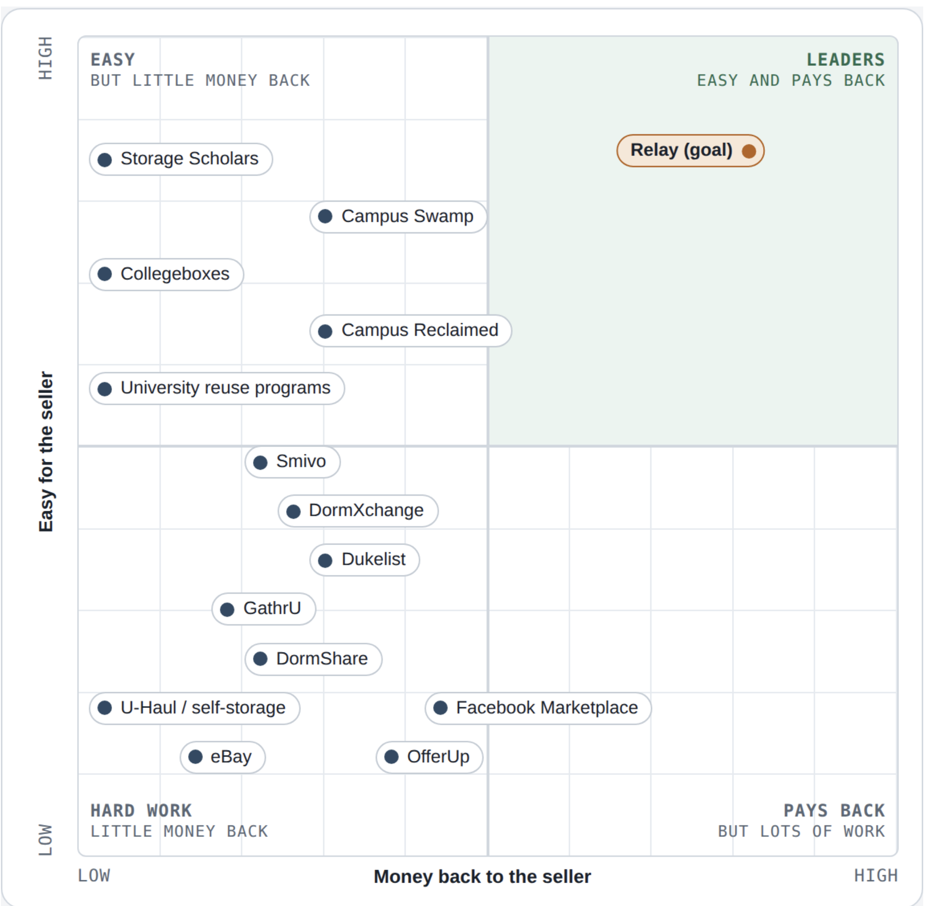

This is the Buyer Graph:
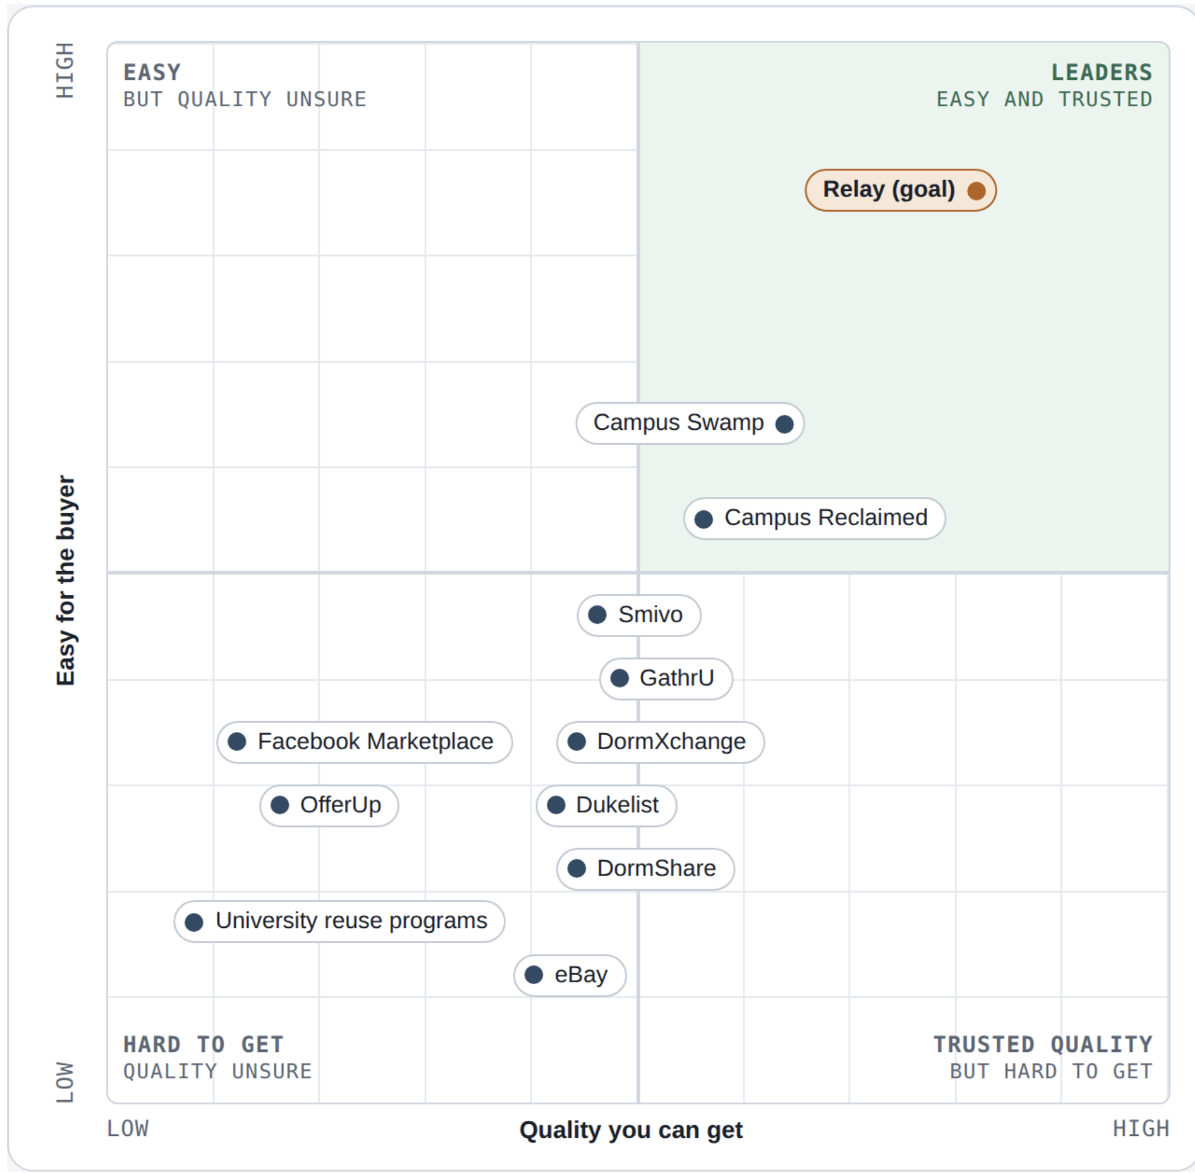

Part 4 — SWOT Analysis

4A. AI-generated SWOT (Kush)
AI writes · student does not edit.
THE AI WRITES THIS — paste the AI's output here; you validate it in the next section
Ask the AI to pick one Leaders-Quadrant leader and build a SWOT comparing that leader to the other competitors, focused on problem-solving effectiveness. Paste it here, and record which leader it chose.

Problem-solving lens for the SWOT: Strengths/Weaknesses = how well it solves the problem · Opportunities = where the problem remains unsolved · Threats = from stronger problem-solvers.
Selected leader competitor | Storage Scholars

Strengths:
Provides pickup, storage, and delivery specifically for college students.
Solves the timing problem between move-out and the next school year.
Offers a more convenient service than students renting storage and moving furniture themselves.
Has an existing network of university partnerships and serves many college campuses.
Provides inventory tracking and climate-controlled storage.
Storage Scholars reports typical summer costs of approximately $300–$500, showing that students already pay for summer storage services.

Weaknesses:
Primarily stores and returns items to the same student instead of helping students sell furniture to incoming students.
Students must pay storage fees even if they ultimately want to get rid of their furniture.
The service does not create a marketplace where incoming students can browse and reserve used furniture.
It may be expensive for students who only want to sell one or two large items.
Its value depends on reliable pickup and delivery operations during crowded move-out and move-in periods.
Storage Scholars does not appear to focus specifically on connecting graduating students with incoming students at the same university.

Opportunities:
Relay could partner with Storage Scholars or similar storage providers instead of building every storage facility itself.
Relay could target students who want to sell furniture rather than keep it.
A reservation system could allow incoming students to purchase furniture before arriving on campus.
Relay could reduce waste by keeping usable furniture from being donated or thrown away.
Partnerships with university housing offices and apartment complexes could provide storage space and reliable access to students.
Relay could offer lower prices by earning revenue from completed sales, buyer reservation fees, delivery fees, or storage charges.

Threats:
Storage Scholars could add a resale or student-to-student marketplace.
Existing marketplaces such as Facebook Marketplace already have large user bases and strong name recognition.
Universities could create their own move-out donation and resale programs.
Students may choose free alternatives such as Facebook Marketplace, Craigslist, donation, or leaving furniture on the curb.
Damaged, stolen, or unsold furniture could create storage costs and reduce Relay’s profit.
Relay would need enough sellers and buyers at the same university for the marketplace to work effectively.

4B. Your own SWOT (Kush)
Student writes · NO AI for your strategic judgments · validate with evidence.
STUDENT WRITES THIS — the AI reads it as context but must not edit it
Perform your own SWOT of one competitor versus your future product idea. You may pick the same or a different competitor than the AI chose.

→ Feeds Slides 3–5
Since you haven't locked a solution yet, focus on: the problems you want to solve vs. those the competitor solves; the markets/segments you target vs. theirs; the unique value you could give that they don't; and the early adopters you'd target (possibly an unaddressed population). Be explicit about uncertainty.
Validate claims with evidence — funding rounds, testimonials, regulatory approvals, partnerships — and mark clearly where you disagreed with or corrected the AI.
Selected competitor | Storage Scholars

Strengths | Weaknesses
Helps incoming students network with graduating students | Needs enough buyers and sellers from the college to be profitable, which may not be possible at state and local colleges
Solves problem of not having anywhere to put items from May-August (summer) | There are high operational costs and high likelihood of damages
Furniture can be reused | There is very low demand during the school year - it is a seasonal business

Opportunities | Threats
Partner with universities and relocation apartments | Facebook Marketplace and university specific sites offer an easier and tech-friendly alternative that students may prefer
Offer furniture to be delivered before arrival, so it is already there for the customer | Uncertain variable demand and large periods of low demand
Use Duke as a proof of concept to expand to other universities | Unsold and damaged furniture can lower profits

The AI correctly identified Storage Scholars as a strong competitor to Relay. However, Storage Scholars does not provide the complete solution that Relay provides because it only stores the student’s belongings. Relay transfers furniture from outgoing students to incoming students. Storage Scholars is a direct competitor for storage and delivery, but not a direct competitor for reselling.

Part 5 — Harvey Balls

5A. Your starting attributes (Mihir)
Student writes · NO AI · do this BEFORE asking the AI for criteria.
STUDENT WRITES THIS — DO NOT USE AI HERE
Create your own list of 6–8 attributes and do a rough Harvey Ball scoring of several competitors yourself first.

Your 6–8 attributes and rough scores:
- Money back
- Ease to sell
- Summer hold
- Pickup
- Delivery
- Quality check
- At Duke

Scale: 0 = none, 1 = low, 2 = okay, 3 = good, 4 = strong
Facebook Marketplace: Money back 2 | Ease to sell 1 | Summer hold 0 | Pickup 0 | Delivery 0 | Quality check 1 | At Duke 4
Dukelist: Money back 2 | Ease to sell 1 | Summer hold 0 | Pickup 0 | Delivery 0 | Quality check 2 | At Duke 2
Campus Swap: Money back 1 | Ease to sell 4 | Summer hold 4 | Pickup 4 | Delivery 2 | Quality check 3 | At Duke 0
Campus Reclaimed: Money back 1 | Ease to sell 3 | Summer hold 3 | Pickup 3 | Delivery 0 | Quality check 2 | At Duke 0
Storage Scholars: Money back 0 | Ease to sell 4 | Summer hold 4 | Pickup 4 | Delivery 4 | Quality check 0 | At Duke 4
Collegeboxes: Money back 0 | Ease to sell 3 | Summer hold 4 | Pickup 3 | Delivery 4 | Quality check 0 | At Duke 2
Duke donation bins: Money back 0 | Ease to sell 4 | Summer hold 1 | Pickup 1 | Delivery 0 | Quality check 1 | At Duke 4
Relay (us): Money back 3 | Ease to sell 4 | Summer hold 4 | Pickup 4 | Delivery 4 | Quality check 4 | At Duke 3

5B. AI-generated Harvey Ball matrix (mihir)
AI writes · student does not edit.
THE AI WRITES THIS — paste the AI's output here; you validate it in the next section
Ask the AI to suggest 8–10 criteria; merge them with yours into 15–20. Then ask it to score ALL competitors. Paste its categorized matrix here.

The AI should organize 10–20 criteria into meaningful categories (e.g., Market Factors, Feature/Function, Customer Segments, Service Delivery, Technology — chosen for YOUR domain), with rows = competitors and columns = criteria, using the symbols ● ◕ ◐ ◔ ○.
AI output — categorized Harvey Ball matrix:
Competitor | 1 | 2 | 3 | 4 | 5 | 6 | 7 | 8 | 9 | 10 | 11 | 12 | 13 | 14 | 15 | 16 | 17
Facebook Marketplace | ◐ | ◔ | ◔ | ○ | ○ | ○ | ◔ | ◐ | ◕ | ○ | ◔ | ○ | ◔ | ● | ● | ● | ◐
OfferUp | ◐ | ◔ | ◔ | ○ | ○ | ◔ | ◔ | ◔ | ◕ | ○ | ◔ | ○ | ◐ | ◔ | ◕ | ● | ◐
Craigslist | ◐ | ◔ | ◔ | ○ | ○ | ○ | ◔ | ◔ | ◕ | ○ | ○ | ○ | ○ | ◔ | ◐ | ● | ◔
eBay | ◐ | ◐ | ◕ | ○ | ○ | ◐ | ○ | ◐ | ◐ | ◔ | ◐ | ○ | ● | ○ | ● | ● | ◔
Dukelist | ◐ | ◔ | ◔ | ○ | ○ | ○ | ◔ | ◔ | ◕ | ◔ | ◔ | ◕ | ◔ | ● | ◐ | ○ | ◐
Campus apps* | ◐ | ◔ | ◔ | ○ | ○ | ○ | ◔ | ◔ | ◕ | ◔ | ◔ | ● | ◐ | ◔ | ◔ | ◐ | ◔
Group chats / Instagram | ◐ | ◐ | ◔ | ○ | ○ | ○ | ◔ | ◔ | ◕ | ◔ | ◐ | ◕ | ○ | ● | ◐ | ○ | ◔
Campus Swap | ◔ | ● | ◐ | ● | ● | ◐ | ● | ● | ◕ | ◕ | ◕ | ◐ | ◕ | ○ | ◔ | ◔ | ●
Campus Reclaimed | ◔ | ◕ | ◔ | ◕ | ◐ | ○ | ◐ | ◕ | ● | ◐ | ◐ | ◔ | ◐ | ○ | ◔ | ○ | ◕
Storage Scholars | ○ | ◔ | ○ | ● | ● | ● | ◕ | ○ | ○ | ◔ | ○ | ○ | ◕ | ● | ◕ | ● | ◔
Collegeboxes (U-Haul) | ○ | ◔ | ○ | ● | ◕ | ● | ◔ | ○ | ○ | ◔ | ○ | ○ | ◕ | ◐ | ◕ | ● | ◔
Self-storage units | ○ | ○ | ○ | ● | ○ | ○ | ● | ○ | ○ | ○ | ○ | ○ | ◐ | ◕ | ● | ● | ◔
Duke donation programs | ○ | ● | ○ | ◔ | ◔ | ○ | ◐ | ◔ | ● | ○ | ◔ | ◕ | ◔ | ● | ◐ | ○ | ●
Buying new | ○ | ○ | ○ | ○ | ○ | ● | ● | ● | ◔ | ● | ● | ○ | ● | ● | ● | ● | ○
Relay (goal) | ◕ | ● | ◕ | ● | ● | ● | ● | ● | ◕ | ● | ● | ● | ◕ | ◕ | ○ | ○ | ●
Key
- Seller Value: 1 Money back · 2 Ease to sell · 3 Payment certainty
- Logistics & Timing: 4 Summer hold · 5 Pickup · 6 Delivery · 7 Big furniture
- Buyer Value: 8 August supply · 9 Low buyer price · 10 Reserve before arrival · 11 Quality check
- Trust & Safety: 12 Verified students · 13 Protection if something goes wrong
- Market Position: 14 At Duke · 15 User base · 16 Multi-campus reach · 17 Keeps items out of landfill
*Campus apps = DormXchange, DormShare, Smivo, GathrU. Buying new = IKEA, Amazon, Target.
● strong · ◕ moderate-high · ◐ moderate-low · ◔ low · ○ none / not applicable

5C. Your final Harvey Ball matrix (Mihir)
Student writes · this is the graded version.
STUDENT WRITES THIS — the AI reads it as context but must not edit it
Build your final matrix covering ALL competitors (AI + your own), focused on the criteria that matter most to your future product strategy.

→ Feeds Slide 6
Specifically note what you changed from the AI: categories added/removed and why; ratings you changed and why (with evidence); criteria added/removed and why. Highlight the important attributes the AI missed and the scores you disagree with.
Your final Harvey Ball matrix and the changes you made (with evidence):

Final Harvey Ball Matrix
Competitor | 1 | 2 | 3 | 4 | 5 | 6 | 7 | 8 | 9 | 10 | 11 | 12 | 13 | 14 | 15 | 16 | 17 | 18
Facebook Marketplace | ◔ | ◔ | ● | ◔ | ○ | ○ | ○ | ◔ | ◐ | ◕ | ◐ | ○ | ◔ | ○ | ◔ | ● | ● | ◐
OfferUp | ◔ | ◔ | ◕ | ◔ | ○ | ○ | ◔ | ◔ | ◔ | ◕ | ◔ | ○ | ◔ | ○ | ◐ | ◔ | ◕ | ◐
Craigslist | ◔ | ◔ | ● | ◔ | ○ | ○ | ○ | ◔ | ◔ | ◕ | ◔ | ○ | ○ | ○ | ○ | ◔ | ◐ | ◔
eBay | ◐ | ◐ | ◔ | ◕ | ○ | ○ | ◐ | ○ | ◐ | ◐ | ◔ | ◔ | ◐ | ○ | ● | ○ | ● | ◔
Dukelist | ◔ | ◔ | ● | ◔ | ○ | ○ | ○ | ◔ | ◔ | ◕ | ◔ | ◔ | ◔ | ◕ | ◔ | ● | ◐ | ◐
Campus apps* | ◔ | ◔ | ● | ◔ | ○ | ○ | ○ | ◔ | ◔ | ◕ | ◔ | ◔ | ◔ | ● | ◐ | ○ | ◔ | ◔
Group chats / Instagram | ◔ | ◐ | ● | ◔ | ○ | ○ | ○ | ◔ | ◔ | ◕ | ◔ | ◔ | ◐ | ◕ | ○ | ● | ◐ | ◔
Campus Swap | ◔ | ● | ◕ | ◐ | ● | ● | ◐ | ● | ● | ◕ | ◕ | ◕ | ◕ | ◐ | ◕ | ○ | ◔ | ●
Campus Reclaimed | ◔ | ◕ | ● | ◔ | ◕ | ◐ | ○ | ◔ | ◕ | ● | ◐ | ◐ | ◐ | ◔ | ◐ | ○ | ◔ | ◕
Storage Scholars | ○ | ○ | ○ | ○ | ● | ● | ● | ◕ | ○ | ○ | ○ | ◔ | ○ | ○ | ◕ | ● | ◕ | ◔
Collegeboxes (U-Haul) | ○ | ○ | ○ | ○ | ● | ◕ | ● | ◔ | ○ | ○ | ○ | ◔ | ○ | ○ | ◕ | ◔ | ◕ | ◔
Self-storage units | ○ | ○ | ○ | ○ | ● | ○ | ○ | ● | ○ | ○ | ○ | ○ | ○ | ○ | ◐ | ◕ | ● | ◔
Duke donation programs | ○ | ● | ● | ○ | ○ | ◔ | ○ | ◐ | ◔ | ● | ◔ | ○ | ◔ | ◕ | ◔ | ● | ◐ | ●
Buying new | ○ | ○ | ○ | ○ | ○ | ○ | ● | ● | ● | ◔ | ● | ● | ● | ○ | ● | ● | ● | ○
Relay (goal) | ◕ | ● | ◕ | ◕ | ● | ● | ● | ● | ● | ◕ | ● | ● | ● | ● | ◕ | ◕ | ○ | ●
Key
- Seller Value: 1 Money back · 2 Ease to sell · 3 Low cost to seller · 4 Payment certainty
- Logistics & Timing: 5 Summer hold · 6 Pickup · 7 Delivery · 8 Big furniture
- Buyer Value & Trust: 9 August supply · 10 Low buyer price · 11 Easy for buyer · 12 Reserve before arrival · 13 Quality check · 14 Verified students · 15 Protection if something goes wrong
- Duke Market Fit: 16 At Duke · 17 User base · 18 Keeps items out of landfill
*Campus apps = DormXchange, DormShare, Smivo, GathrU. Buying new = IKEA, Amazon, Target.
● strong · ◕ moderate-high · ◐ moderate-low · ◔ low · ○ none / not applicable

What we changed from the AI
Categories
- We put Trust & Safety inside Buyer Value. It only had 2 items, and trust matters most to buyers.
- We changed Market Position to Duke Market Fit, because we're starting at Duke.
Criteria
- Added "Low cost to seller." Storage companies don't just pay sellers nothing. Sellers pay them: Storage Scholars costs about $300–$500 for a summer.
- Added "Easy for buyer." This is on our buyer quadrant, so it belongs here too.
- Removed "Multi-campus reach." We're starting at Duke only, so this doesn't matter yet.
Scores we changed
- Money back for Facebook, OfferUp, Craigslist, Dukelist, campus apps, and group chats: ◐ → ◔. In May, everyone is selling and no one is buying, so prices drop. For example, a $100 table sells for about $20. eBay stays at ◐ because it has buyers across the country.
- Storage Scholars and Collegeboxes, ease to sell: ◔ → ○. They don't sell anything.
- Collegeboxes, at Duke: ◐ → ◔. It started at Duke in 1999, but today Storage Scholars is Duke's storage partner.
- Campus apps, at Duke: ◔ → ○. We found no sign they are used at Duke.
- Campus Reclaimed, big furniture: ◐ → ◔. It mostly sells small items. Its most expensive furniture was $99.
- Duke donation programs, summer hold: ◔ → ○. Donations go to TROSA and Goodwill, not to new students.
What the AI missed
- What it costs the seller, and how easy it is for the buyer.
- The May price drop. The AI ignored timing.
- Location. Campus Swap does almost everything but is at UNC. Storage Scholars is already at Duke.

5D. Harvey Ball summary (optional — for Slide 7) (Mihir)
Student writes.
→ Feeds Slide 7 (if needed)
Summarize what the analysis reveals: key discoveries; attributes to prioritize or ignore; competitors to deprioritize; and which competitors are most problematic and why.
Your Harvey Ball summary:
Harvey Ball Summary
Key discoveries
- No one does it all. Some sell but don't store. Others store but don't sell.
- Campus Swap is closest, but it's at UNC and pays sellers little.
- Selling in May pays badly, because buyers don't come until August.
- For buyers, our real rival is buying new.
Focus on
- Money back
- Ease to sell
- Summer hold
- Low price for buyers
- Being at Duke
Ignore for now
- Multi-campus reach
- User base
Less important competitors
- Craigslist, OfferUp, eBay
- Small campus apps
- Self-storage
- Campus Reclaimed
Biggest threats
- Campus Swap: same idea, 10 miles away.
- Storage Scholars: already at Duke. Could add resale, or could be a partner.
- Facebook Marketplace: free, and everyone uses it.
- Duke donation bins: free and easy.

Part 6 — Your Story (NO AI)
STUDENT WRITES THIS — DO NOT USE AI HERE
These final sections are entirely your own. This is where you show independent thinking — the core of your grade.

6A. Learning & critical analysis (Sam)
Student writes · NO AI.
Tell the story of your analysis. Possible elements:
- What you discovered through your own independent research.
- Where and why you corrected the AI.
- 2–3 strategic insights from combining human and AI analysis.
- What the AI missed or misunderstood, and how your domain knowledge shaped the outcome.
- Problem-solving gaps and opportunities you uncovered.
Your learning narrative:
There are indeed some websites aimed at tackling this problem within universities, but they don’t have a large selection of furniture and items. AI sometimes did too much segmentation for the harvey balls table and other things that were not as helpful as it might have been intending. AI missed how regionality can really influence the market of this type of product, for example how useful it is to know where these competitors are and how location changes functionality.

6B. Lean Canvas update (sam) (mihir send the original)
Student writes · NO AI.
Update your Lean Canvas using your own insights from this competitive analysis:
- Customer problems
- Unique value proposition
- Channels and differentiation
- Competitive advantages
Your updated Lean Canvas (or attach it separately and note that here):

6C. Reflection on AI collaboration (sam)
Student writes · NO AI.
Where did you agree or disagree with the AI? What did it surface that you hadn't considered? What assumptions became clearer? What changed in your Lean Canvas because of the full competitive analysis?
Your reflection:
AI brought up a lot of competitors that aren’t direct competitors but have concepts that are very similar and meet the problem we’re trying to solve using a different solution.

Submission Map & Checklist
Your slide deck draws from these sections:
Slide | Source section | Show
Slide 1 | Part 2 (2A + 2B) | Your and the AI's competitors; discrepancies; companies you added; how well each solves the problem.
Slide 2 | Part 3 (3C) | Final Leaders Quadrant with commentary on what you changed or added.
Slides 3–5 | Part 4 (4A + 4B) | Selected SWOTs with deep insight and strategic direction; mark where you corrected the AI.
Slide 6 | Part 5 (5C) | Full Harvey Ball slide; highlight criteria you added and scoring disagreements with evidence.
Slide 7 | Part 5 (5D) | Optional Harvey Ball summary (key discoveries, attributes to prioritize/ignore, competitors to deprioritize).
Narrative | Part 6 (6A) | Learning & critical analysis (no AI).
Lean Canvas | Part 6 (6B) | Updated Lean Canvas (no AI).

Before submitting, confirm:
- Pre-work done before any AI use (research, 5+ known competitors, draft dimensions)
- Problem description and JTBD written (Part 1)
- AI competitor list pasted, and at least 3 descriptions fact-checked; missed competitors added (Part 2)
- AI and final Leaders Quadrants complete; placement changes explained with evidence (Part 3)
- AI and your own SWOTs complete; corrections marked with evidence (Part 4)
- AI and final Harvey Ball matrices complete; added criteria and scoring disagreements noted (Part 5)
- Learning narrative and Lean Canvas update written with NO AI (Part 6)
- Evidence throughout that you validated rather than accepted the AI's output

Appendix — Legends

Harvey Ball symbols
Symbol | Meaning
● | Strong / significant emphasis
◕ | Moderate-high emphasis
◐ | Moderate-low emphasis
◔ | Low emphasis
○ | None / not applicable

Section access legend
Box style | Meaning
Blue | Student writes; AI may read as context but must not edit.
Green | AI writes; you then validate and correct in the next section.
Amber | Read it; do not edit it.
Blue with red edge | Student writes with NO AI — your own work only.

Harvey Ball reference: the Gartner “Summary of Major Vendor Emphasis” chart shows how categories (e.g., build vs. deliver services, services delivered, private offerings) can structure a Harvey Ball matrix. Build a similar multi-category structure for your own problem domain.

